Sep 2023 Vol. 53 # 9

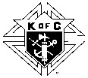
THE COLUMBAN NEWSLETTER
Knights of Columbus Columban Council 6192
GRAND KNIGHT ~ Ray Romero Sr.

General Membership Meeting..……..……........ 5 Sep at 7:00 p.m.
Planning/Building Corporation Meeting.....…. 19 Sep at 6:00 p.m.

BUILDING CORPORATION OFFICERS
President Dave Cote 402-917-2683 – cote.dave16@yahoo.com
Vice-President Ken Madison 402-210-5255 – kenmadisonjr@yahoo.com
Treasurer Ray Guggenberger 402-681-6572 -- rguggenberger@cox.net
Secretary Ray Romero Sr. 402-541-2092 –-romerorf@gmail.com

Council 6192 web site: Direct: www.koc6192.com
Council 6192 web site thru St. Mary’s: www.stmarysbellevue.com Knights of Columbus State web site: NebraskaKofC.org; Knights of Columbus Supreme web site: KofC.org

Council 6192 Facebook: Go to Facebook-Enter in search bar ‘K of C Columban Council 6192’ Knights Event Center: Go to Facebook-Enter in search bar ‘Bellevue Knights Event Center’

CHAPLAIN: Dear Brothers of our Order,
The lazy days of summer are coming to an end. School and parish programs are starting up again. One program I would like to promote to you men is St. Mary's That Man is You. This is a men's group that meets on Friday mornings at 5:30 with breakfast, a video presentation and then group discussion. You then are done by 7AM so you can go to work or upstairs and go to the Mass. I should say the group meets in the parish center. This is a great way to deepen your relationship with Jesus and other men who follow the Lord. That Man is You is going to begin Friday September 8, the Birthday of the BVM. For more information or if you want to attend, contact our Brother Knight Deacon Ted Menzel. God Bless fr del lape

GRAND KNIGHT: August was another busy month of community and parish activities. We again participated in the Bellevue Police Department’s National Night Out. About a dozen of our council members served ice cream sundaes and bottled water to over 400 participants. We also gave away four bicycles: two for older kids and two for younger kids. We also participated in the annual Big Red Night with about 225 in attendance. It was a great success. And, as in previous years, we participated in the annual Arrows to Aerospace parade, pulling a Knights of Columbus float, as well as handing out Tootsie Rolls to kids along the route. As we do every third Saturday, we prepared 150 sack lunches and distributed them to residents of Siena Francis House and other homeless people in the streets. We also again participated in Cops and Bobbers at Gilmore Lake, a police-sponsored event where we showed young children how to fish. Finally, at the end of the month, we set up and grilled hamburgers and hot dogs for a picnic at our Roundtable Parish, Offutt’s Our Lady of Peace. I sincerely thank all our Brother Knights and families who participated in any of these events. Looking ahead in September, some of our events are St. Mary’s Parish picnic, a Silver Rose prayer service (see below article), another Feed the Need Sack Lunch, and a Pro-Life Mass and March.

SILVER ROSE: Each year, from early March through mid-December, Silver Roses are stewarded by Knights of Columbus councils along routes from Canada to Mexico. Every stop the Silver Rose makes throughout the pilgrimage is a rosary-centered occasion for Knights, parishioners, and community members to pray for respect for life, for the spiritual renewal of each nation, and for the advancement of the message of Our Lady of Guadalupe. This year our council will be receiving the Silver Rose on Sep 10. When we have a firm date and time for the prayer service, we will provide the information.

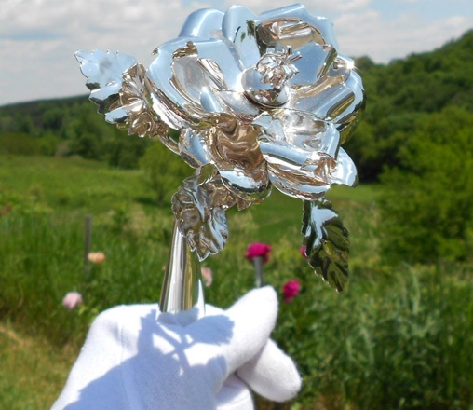

POPE’S SEPTEMBER PRAYER INTENTION: For people living on the margins—We pray for those persons living on the margins of society, in inhumane life conditions; may they not be overlooked by institutions and never considered of lesser importance.

PLEASE PRAY FOR US: Here is a list of our Brother Knights, immediate family members, and widows who are in need of our prayers: Lyle Sypal, Glenn Millerd Jr., and Roger Tschampl-Diesing. This list is for our Brother Knights and the widows of our deceased Brothers who are not on our prayer chain so we are aware of their need for prayers. If we missed anyone in need of prayers, please contact Ray Guggenberger or Ray Romero Sr. Please contact Ray Guggenberger via phone or email if you know of a Brother Knight or a widow of a deceased Brother Knight who is sick or in distress.

FIELD AGENT REPORT: For insurance and savings needs contact Matt Harm, Field Agent (402) 917-2342

COUNCIL SHIRTS AND CAPS: Our council has a local supplier for our shirts and baseball caps. The supplier has asked that all orders go through one person to avoid confusion and duplication. If you want a shirt or cap, please contact Ray Guggenberger at 402-681-6572 or email rguggenberger@cox.net. We also have some t-shirts and sweatshirts on hand. For 4th Degree clothing, please contact Mike Parente mparente77@gmail.com or call (402) 651-7196.

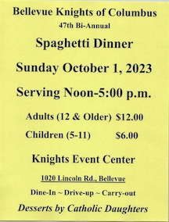

COUNCIL CALENDAR OF EVENTS (Sep-Oct 2023)

Sep 4, Mon Labor Day Oct 1, Sun Spaghetti Dinner
Sep 5, Tue Council Membership Meeting (7-8 PM) Oct 2, Mon Serve dinner at Christlife (Parish Hall)
Sep 10, Sun Parish Picnic (1:30-4:30 PM) Oct 3, Tue Council Membership Meeting (7-8 PM)
Sep 10, Sun Silver Rose (Time TBD) Oct 7, Sat Tootsie Roll Drive & Highway Cleanup
Sep 16, Sat Feed the Need (9-11 AM) Oct 8, Sun Tootsie Roll Drive
Sep 19, Tue Council/Ind. Corp Planning Mtg (6-8 PM) Oct 9, Mon Columbus Day
Sep 23, Sat Pro-Life Mass and March (8-10 AM) Oct 17, Tue Council/Ind. Corp Plan. Mtg (6-8 PM)

KNIGHTS EVENT CENTER SCHEDULE

The Knights Event Center rentals for September and October include a Bridal Show, a Bellevue Bazaar, Quinceanera, 4 wedding receptions, Ducks Unlimited and a parish picnic

